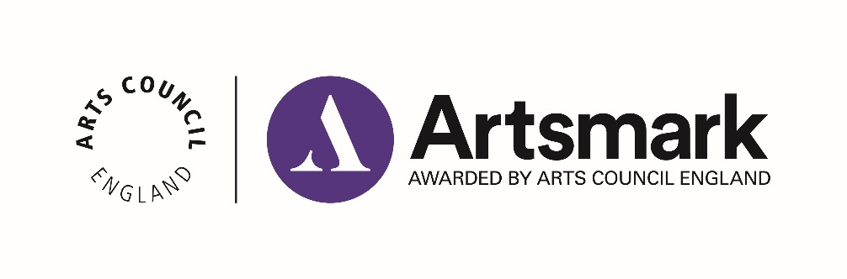

Statement of Impact (formerly Case Study)
Application paperwork 2 of 2.

Name of school/education setting
DfE number | _ _ _ / _ _ _ _

Support
We are here if you need us.
Download our guidance on how to complete your Statement of Impact:
https://www.artsmark.org.uk/about/artsmark-award-document-downloads

Get in touch with your Bridge organisation, who offer support throughout your Artsmark journey. Their details can be found online: https://www.artsmark.org.uk/Bridge

Context – up to 150 words
If there have been changes to the context of your school or education setting since the submission of your Statement of Commitment, please describe them here.
(Enter your answer here)

Question 1 – up to 500 words
Reflecting back on your Statement of Commitment and the Artsmark Award criteria, what was successful in your Artsmark journey and how did you achieve this?
(Enter your answer here)

Question 2 – up to 500 words
What challenges did you face and how did you overcome them? Were there any differences from your original plans and how did you implement them?
(Enter your answer here)

Question 3 – up to 500 words
What impact has the Artsmark journey had on your children and young people and how can you evidence this?
(Enter your answer here)

Question 4 – up to 500 words
What impact has the Artsmark journey had on your staff, leadership team and wider community and how can you evidence this?
(Enter your answer here)

Question 5 – up to 500 words
How has your Artsmark journey influenced change to your strategic values and the priorities in your strategic improvement plan?
(Enter your answer here)

Question 6 – up to 500 words
What are your future goals and ambitions for developing the role of arts and culture in your setting?
(Enter your answer here)

Approval
Click the box to agree to the statement and enter the name and date this was approved.
☐ I confirm that I have read, approved and endorsed the Statement of Impact and agree that it represents an accurate evaluative account of the Artsmark journey

Headteacher Name:

Date:

☐ I confirm that I have read, approved and endorsed the Statement of Impact and agree that it represents an accurate evaluative account of the Artsmark journey

Chair of Governors Name:

Date:

Checklist
Make sure your Statement of Impact is complete before you submit to us.
☐ My school/setting name is written at the top of this document
☐ My DfE number is at the top of this document and matches the one I registered with
☐ If applicable, my answer to the Context question has no more than 150 words
☐ My answers to Questions 1-6 have no more than 500 words each
☐ The Headteacher and Chair of Governors have approved this document

Ready to submit?
You must submit your Statement of Impact within two years of your Statement of Commitment.
Email your Statement of Impact as an attachment to artsmark@artscouncil.org.uk
We will confirm receipt within five working days.

