**Liverpool Curriculum and Culture Pilot**

**A Curious Minds Summary Evaluation on behalf of School Improvement Liverpool**

DrStephanie Hawke. November 2014  
Map featuring organisations involved in the Curriculum and Culture Pilot



## Background and Context

The publication of the Mayor of Liverpool’s Education Commission Report in July 2013 inspired a partnership between School Improvement Liverpool and Curious Minds.

The report’s fourth recommendation was as follows:

An enhanced Liverpool curriculum should be developed that draws together best practice in the city in relation to the early years’ foundation stage, the national curriculum, the local cultural and sporting contribution and the effective development of life and employment skills. This enhanced curriculum should be made available systematically to every Liverpool learner, and its progress and impact should be monitored as part of the core work of all schools.

(Mayor of Liverpool, 2013: 54)

The Liverpool Curriculum and Culture programme was informed by the Area Based Curriculum model. There are a number of ABC pilots and the Royal Society for the Encouragement of the Arts, Manufactures and Commerce (RSA) piloted three projects in Manchester between 2008 and 2009 funded by Manchester City Council:

The aim of an ‘area based curriculum’ seems elegant in its simplicity: to enhance the educational experiences of young people “by creating rich connections with the communities, cities and cultures that surround them by distributing educational efforts across the people, organisations and institutions of the local area.”

(RSA, 2009, cited in Facer, 2009: 2)

The pilot grew out of a broad consensus that a highly centralised and standards driven process of curriculum design has yielded little success in tackling educational inequalities and in raising attainment (Hargreaves, 2009; Fullen, 2006 cited in Facer, 2009: 7) and that there is urgent need to explore how to re-engage teachers and schools in the process of curriculum design.

In Manchester the projects focused less upon specific learning outcomes and more upon responsiveness to local circumstances and the development of individual students (Facer, 2009:9). This is an approach to curriculum making rooted in process, one that allows students to actively generate knowledge that has real meaning to them, rather than to passively receive it. The pedagogy was underpinned by ‘inquiry-led’ approaches to learning.

Alfred North Whitehead argued that the purpose of learning is not simply to regurgitate inert knowledge but to transform it by reacting to, shaping or applying it (Whitehead, 1923). In this vein, the Area Based Curriculum is one that focuses on the locality of schools and communities to make a curriculum that is ‘relevant’ to children’s lives and experiences and thereby will enhance their engagement with learning (Facer, 2009: 10).

Environmental psychology has shown that a strong sense of place can boost an individual’s self-esteem and perception of self-identity which can ultimately result in greater self-efficacy (Twigger, Ross and Uzzell, 1996). It follows that an Area Based Curriculum should generate positive outcomes for the individual learner not just in terms of subject areas but more broadly for individual and community identity, belonging and self-belief.

### Impact for Cultural Organisations

Cultural organisations described the impact of the project in terms of understanding and developing an offer for new age groups, particularly KS1 and primary. They hoped they had developed relationships that might become longer term with their local schools and they were surprised by the aspects of the curriculum that presented most difficulty to teachers. Many grasped the opportunity to pilot their workshops or develop their ideas for this particular market:

“… in terms of trying to get the primary school stuff off the ground, it’s something that as the schools return next week we’ve got a new kind of action plan.”

“Our problem as a lot of organisations, is just capacity. Because we have a strong secondary school model that almost looks after itself…”

“I think that has been useful to be able to work with the teachers and work out which areas they were struggling on and what I found really interesting was that there were certain areas that I was quite surprised that they were struggling to kind of bring them to life.”

“I would like to see that being the beginning of a long term relationship… so we will have to make sure that we follow up there as well and can do that…. It’s definitely built the relationship; it’s got us closer to building the relationship.”

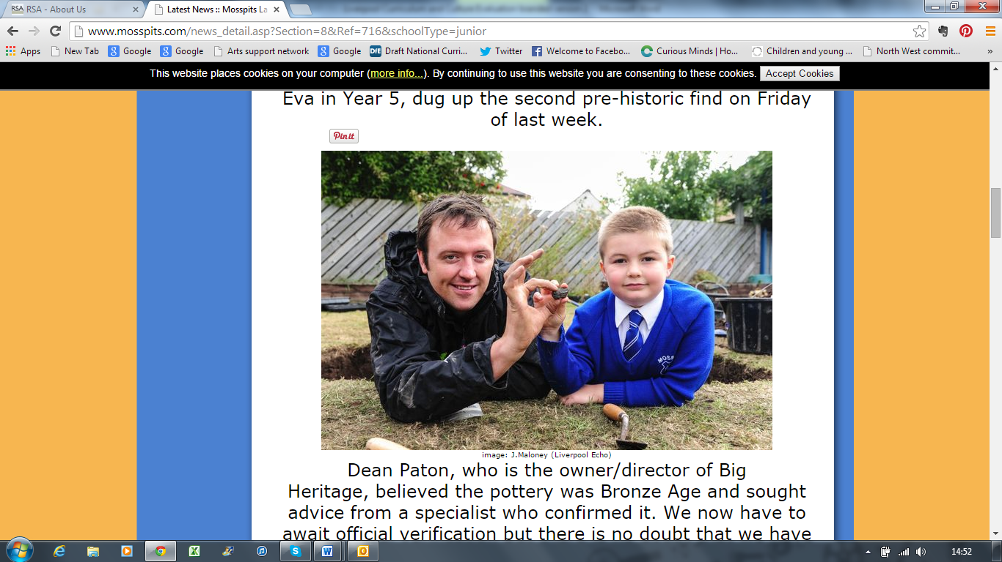

Children at Mosspits Lane Primary School discovered a piece of Bronze Age pottery in their school grounds whilst taking part in an archaeological excavation with Dean Patton and his company, Big Heritage.

### Impact for Children

The project had positive impacts for the children in terms of: subject knowledge and understanding; children’s cultural capital and confidence to visit cultural venues outside of school time; for the involvement and engagement of parents and grandparents; for children’s pride and sense of belonging; and also for their enjoyment of learning and career aspirations.

* **Subject knowledge and understanding**

“You know they’ve gone above and beyond what I could ever have done myself and I think the children have remembered a lot.”

“…it actually gave them lots of questions.”

“They can actually use maps they can use keys with maps, they’ve used all of that. But also that they have some sense of what a fantastic place this was in the ‘60s and that that culture that was started there continued on and that Liverpool is still a beacon for music and for culture throughout the world and just becoming aware of the number of people that actually come into Liverpool to visit it.”

* **Cultural capital and confidence to visit cultural venues outside of school time**

One teacher explained the context for her pilot project: “I’m only talking about my children here, they tend to be culturally closed, so they tend to be focused on Liverpool 8, and everything else is a bit terrifying for them to be perfectly honest.”

Children at Kingsley Primary School had visited Unity Theatre and explained how comfortable they would now be to go back there in their own time:

“…we’d be like we know everyone and people would just be like ‘we know everyone’. It would feel different and I wouldn’t feel awkward.”

“So in many ways it’s very important I think for the school then to say, you know, the Unity is only down the road and the kids will go, ‘oh, the Unity, we’ve been there’.”

* **Involvement and engagement of parents and grandparents**

“Next year we will develop that further and I think with the teacher’s trail at the museum, we’re looking to try and do one for families as well so that we could give that as a signpost you know in your holidays or the weekend you can go and support, and then they could perhaps go and visit with their families and that would be another place that they could go and see.”

“Obviously the kids go home and they talk about it… the Unity do some things with parents and we hoped … that we actually take our parents to see their children perform in the Unity. And say: this is here! This is what this building actually looks like, it’s here, down the road.”

“Quite a number of my parents had been to visit it since we took the children so it’s very interesting. Very much so it has engaged parents and that’s what the interesting thing about it was.”

“I think for me one of the things for me was that you know, so many of the children went back into the city centre with their parents after we’d visited and took them to see what they’d seen”

* **Enjoyment**

“… they were just blown away by it really”

* **Pride and sense of belonging**

“I think very definitely it’s given them an insight into their city and a pride in their city which I think is important.”

“With St Vincent’s, knowing Monique (artist from Brouhaha International) and Monique lives in the community as well and getting to meet her and see her and you know, and know that she’s not that much older than them. She’s made, you know, she’s made such a big impact in the community, giving them a sense of place and the contribution that they themselves could make as young people to the community just by participating is really important because they all ended up being in the Carnival behind and in front of Monique.”

* **Careers and aspirations**

Children learned not only about their history and geography subjects but also about the cultural organisations they worked with and careers in the arts, as this child explained:

“I liked meeting the people who worked in theatres because now I know that you don’t have to be an actor to work in the theatre. You can be a director. And I asked them questions like, I like to learn about what they do and what inspired them to do that.”

### Impact for Teaching and Learning

Teachers reported that the project reinvigorated enthusiasm for subjects in their schools. They were also given more ideas for art and cultural partners to work with in future, and some were thinking about taking a more strategic approach to arts partnerships, for instance, by making links to the criteria required of Artsmark Gold status.

* **Enthusiasm for subjects**

“It’s been nice talking with other teachers as well and sharing ideas and they’re very motivated and it rubs off on you as well.”

“Well I think it’s definitely made us a bit more excited about geography. Everybody kind of groans when they have to teach geography. And when I did an audit in school, a lot of children didn’t even know what geography was, it’s just basically not taught. But by being involved in the project and being so enthusiastic about it, I think people are starting to see, I think people’s opinions are changing and they’re actually starting to think, no actually it’s not just boring map skills, we can actually make this exciting, we can bring the arts into it, and people are more enthusiastic about teaching it.”

“…the teachers were fairly engaged when they were, when the sessions were being delivered, certainly in Mosspits I know they were, they were very much kind of you know, open to learning themselves from the process and take things on board and maybe just experience new teaching techniques”

“… the project’s really helped to establish the curriculum for next year to be honest because it’s really made me think about the progression, what organisations could fit in where”

“…the plans for next year have definitely changed because of the project.”

“I think for so many different reasons I think it’s been the best topic I’ve ever done.”

* **Arts partnerships**

“…we really need to keep this up, this is really the identity for our school, this is one of the areas where, you know we’re now identified as being, you know, a centre to look at. So I think yeah that will continue. And it’s also I think, given me just different leads to kind of go and you know look at, think about that and try and put that in. I think it’s more accepted now that teachers would very definitely need to do a link (to a cultural partner) for something, that it can’t be left alone.”

“Definitely but I think what we do with it now is that we work with it in a more structured way. It’s always been here at the whim of a teacher whether they do or they don’t participate whereas now it’s going to be much more structured and these are the things available and there’s a much more heightened sense of ‘let’s do it’. You know this is such an important part of children’s education.”

“I think when everybody’s worked with a different organisation, they’ve all given the organisations you know the slant from schools, what we’re working towards. So hopefully organisations will now have a better understanding of what we need in school.”

“I’ve done actually in our curriculum map, how I’ve changed it now… because we do a topic approach now. We do it as a subject based topic, but we’ve put in now, links with cultural organisations and that is new.”

### Bringing the Curriculum to Life

Interviews with teachers highlighted a number of ways in which cultural partnerships brought the curriculum to life and these related to: authenticity of experience for children; engaging parents; giving children real world experiences that could impact upon their career aspirations; and access to subject specific knowledge and resources beyond those available in school.

“…it was so authentic, it really did add something that I feel I couldn’t have brought as a teacher.”

“Very much so it has engaged parents and that’s what was the interesting thing about it.”

“…they’ve talked about it ever since because they actually had the experience of performing in a proper space. For children I think it has to be the performance in that space that brings it alive and makes them think about actors and acting.”

“…he had all of the skeletons and the flints and things like that and he passed it round, so it was really nice to have actual artefacts because I’d been teaching the children the Stone Age and we’d looked at pictures of things for them to understand how we find out about the past you know when it was so long ago.”

## Legacy

Teachers indicated a number of ways in which the Curriculum and Culture Pilot might have a legacy. These related to: the need to continue a network; a continued engagement with art and cultural organisations for curriculum delivery which in some cases will be more strategic (see above 7.2); and cultural organisations being better placed to support primary schools

* **Continued network**

“I think an agenda item for the history network meetings to talk about what resources and support are available would be quite important.”

* **Continued engagement with art and cultural organisations for curriculum delivery**

“…the plans for next year have definitely changed because of the project. We’re definitely going to do South America in Year One, we’re going to use Brouhaha again.”

“…the project’s really helped to establish the curriculum for next year to be honest because it’s really made me think about the progression, what organisations could fit in where…”

“I think it’s more accepted now that teachers would very definitely need to do a link for something, that it can’t be left alone.”

* **Cultural organisations better placed to support primary schools**

“…they’ve all given the organisations you know the slant from schools, what we’re working towards. So hopefully organisations will now have a better understanding of what we need in school.”

“(as a result of our project) with Unity there’s now a workshop available for Ancient Greece.”

## Added Value

The project benefitted from the outstanding knowledge and experience of the curriculum innovation team within School Improvement Liverpool who were able to work alongside teachers in the development of project ideas and in the brokering of partnerships. On the initiative of individual members of this team, the project also achieved:

* A new partnership with Big Heritage available for all primary schools in Liverpool
* A fantastic range of primary and secondary source material on significant Liverpool individuals collated with the help of local archivists
* Additional Arts Award training for schools not already participating in the project
* Schemes of work, case studies, archive materials and contact details of art and cultural organisations available to all Liverpool Schools through the School Improvement Liverpool website.
* A self-directed ‘Climate Trail’ making Liverpool World Museum accessible for the study of geography
* Sharing the learning at two regional events at which representatives from forty arts and cultural organisations attended.

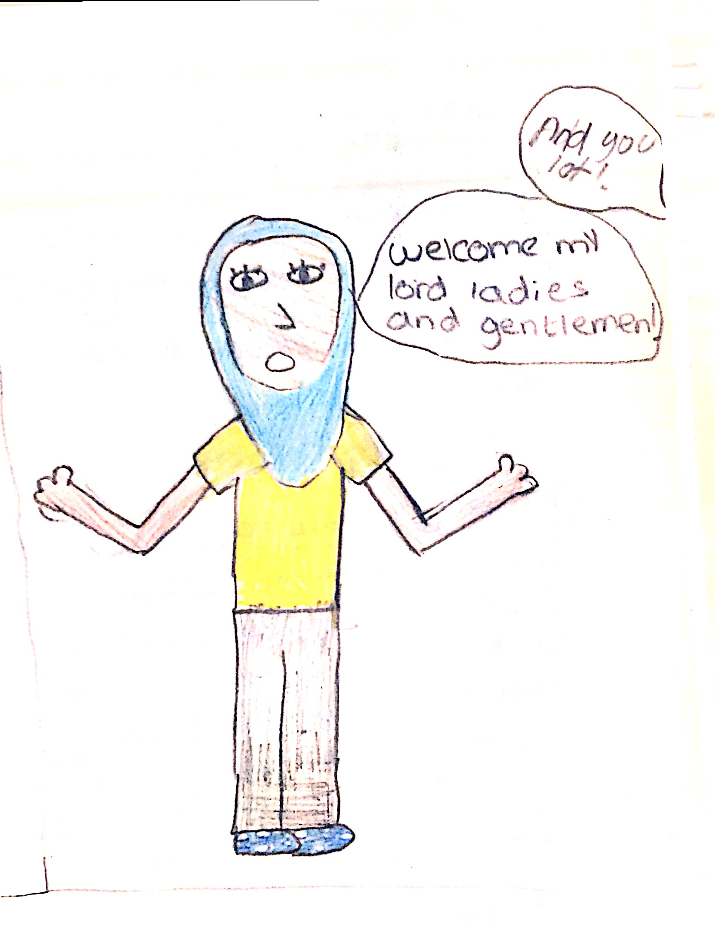

Children at Kingsley Community School worked with Unity Theatre to explore theatre through the ages.

### Evaluation against Objectives

|  |  |
| --- | --- |
| Objective | Achieved |
| 1. Teachers from 15 schools work with Curious Minds, School Improvement Officers and staff in cultural venues to plan and produce a curriculum planning resource for Liverpool Schools based around the new National Curriculum frameworks for history and geography at Key Stage 1, 2 & 3 | 12 schools engaged in 15 pilot projects (some schools opted to pilot both history and geography. Schools and their projects are detailed in Appendix 2. All were primary schools. |
| 1. The same group of teachers work with staff in cultural venues to plan and produce a ‘family learning map’ linked to the new National Curriculum frameworks for history and geography at Key Stage 1, 2 & 3 | A map linking cultural venues to curriculum case studies was produced as part of a printed resource circulated to all schools in the Autumn Term of 2014 |
| 1. The teachers work with Curious Minds to embed Arts Award into planning document and Family Learning map | The final printed resource included case studies, a cultural venues map and index and details of the Arts Award accreditation. |
| 1. The history and geography curriculum is brought to life and made locally relevant and accessible as part of the wider world class offer of cultural education in the city and links are made to the work of Liverpool learning Partnership | Teachers, children and art & cultural organisations reported through in-depth interviews, focus groups and survey questionnaires that the project had brought new resources, skills and ideas to the teaching of the new programmes of study. Children had enjoyed the experience and all case studies and additional resources are available for Liverpool schools online.  At the beginning of the project, only 12% of teachers surveyed felt their history curriculum was locally relevant and none of the teachers felt their geography curriculum was locally relevant. By the end of the project 100% of teachers agreed that their history and geography curriculum was locally relevant.  ***“it was so authentic, it really did add something that I feel I couldn’t have as a teacher”*** |
| 1. The public investment made in Liverpool’s cultural sector is maximised and the education effort is distributed more widely across people, organisations and institutions | All agree that the project had taken steps towards achieving this long term aim. |
| 1. Children and young people appreciate their unique heritage and feel proud to live and learn in Liverpool | Teachers reported that children had developed their sense of belonging to Liverpool and pride in the city. In many cases the pilot projects had engaged parents in their children’s learning leading to further visits to cultural organisations outside curriculum time. |
| 1. The quality and impact of teaching and learning, particularly in history and geography, is improved | Teachers reported the project had reinvigorated enthusiasm for history and geography.  ***“…it’s made us a bit more excited about geography: it’s not just boring map skills, we can actually make this exciting, we can bring the arts into it, and people are more enthusiastic about teaching it…”***  ***“…the plans for next year have definitely changed because of the project…”***  ***“…the project’s really helped to establish the curriculum for next year, it’s made me thing about what organisations could fit in where..”*** |
| 1. Teachers and other practitioners in schools know what quality cultural education looks like and know where to find it | 80% of teachers surveyed agreed that by the end of the project they knew what a quality cultural education offer looked like and new where to find it.  ***“…we will work with (cultural organisations) in a more structured way. It’s always been at the whim of a teacher, whereas now it’s going to be more structured… this is such an important part of children’s education”*** |
| 1. Cultural apartheid is dissipated and the achievement gap is narrowed | The project opened up cultural opportunities and learning to those who for a number of reasons experience barriers and exclusion:  ***“It’s given them an insight into their city and pride in their city which I think is so important”***  ***“I would say that there is a change in the kids and in the excitement that they had because not only could they relate it to their communities, but they were actually kind of understanding it on a wider perspective as well.”*** |
| 1. This model provides a resource through which to map other curriculum areas/ subjects into Liverpool’s cultural offer | Teachers identified cross curricular opportunities in their cultural partnerships and described the relationships they hoped to build with cultural organisations for other subject areas. |
| 1. Teachers will be able to support children aged 7 and above to achieve Arts Award | 15 teachers became Arts Award advisors at Discover and Explore level as part of the project. The training was very popular and as a result School Improvement provided Arts Award training to a second cohort of teachers. |

### Evaluation against ACE Quality Principles

|  |  |
| --- | --- |
| Seven Quality Principles | Reflection on Curriculum and Culture Pilot |
| * striving for excellence | *“… we knew that to maintain (Artsmark Gold) we had to do something different… it was that sense of wanting to inject something new and have some new (cultural) links”* |
| * emphasising authenticity | *“… because it was so authentic, it really did add something that I feel I couldn’t have brought in as a teacher.”* |
| * being inspiring, and engaging | *“… its was just fantastic to give those children at that age, where they can grow up with it …and realise that… it’s not any old place they come from, that Liverpool is known throughout the world.”*  *“For them to see artists that live and work in the community in Liverpool was really important for them…”* |
| * ensuring a positive child-centred experience | *“… I would say that there is a change in the kids and in the excitement that they had because (they could) relate it to their communities.”* |
| * actively involving children and young people | *“… it actually gave them lots of questions.”*  *Children said: “(if we went to the theatre again) we’d be like, we know everyone. It would feel different and I wouldn’t feel awkward”* |
| * providing a sense of personal progression | *“The lovely thing about it is that my children can now open a map of Liverpool and can say, that’s that, that’s that, we did that, we went there.”* |
| * developing a sense of ownership and belonging | *“… we had this big massive group of kids who were doing the dances and you know they felt part of something and a sense of place and they belonged.”* |

### Summary of Partnerships

|  |  |  |
| --- | --- | --- |
| **School** | **Subject and topic** | **Cultural partner** |
| The Trinity Catholic Primary School | History – Stone Age to Iron Age. Literacy – storytelling | Writing on the Wall and Big Heritage |
| St Vincent de Paul Catholic Primary School | Geography: understand geographical similarities and differences through studying the human and physical geography of a small area of the United Kingdom, and a small area in a contrasting non European country | Brouhaha International |
| St Paul & St Timothy’s Catholic Infant School | Brouhaha International |
| Rice Lane Junior School | As above and also biomes (specifically rainforests) | World Museum Liverpool |
| Rice Lane Junior School | History – Stone Age, Bronze Age and Iron Age | World Museum Liverpool |
| Mosspits Lane Primary School | History – look at significant individuals from the past who contributed to national and international achievements | The Comedy Trust |
| Mosspits Lane Primary School | History – a local history study | Mersey Ferries eco-cruise  Big Heritage |
| Monksdown Primary School | Geography – fieldwork and related skills | Chris Price, Healthy Schools Team based at Toxteth Annexe |
| Longmoor Community Primary School | History – World War 1 | Big Heritage |
| Kingsley Community School | Geography – physical geography of Formby | National Trust – coastal ranger |
| King David Primary School | History – Stone Age to Iron Age | Liverpool Parks |
| King David Primary School | History – Stone Age to Iron Age | Liverpool World Museum |
| Windsor Community Primary School | History – a local study (Victorians) | Liverpool Museum  Sudley House |
| Emmaus CE and RC Primary School | History – significant historical people in their locality (incorporating changes within living memory and the lives of significant individuals in the past who have contributed to national achievements)  Geography – skills – use aerial photographs and plan perspectives to recognise landmarks and basic human and physical features; devise a simple map; use and construct basic symbols in a key | The Beatles Story  Museum of Liverpool,  National Trust |
| Blackmoor Park Infant School | Changes in Britain within living memory | The Piermaster’s House, Museum of Liverpool |

## References

Mayor of Liverpool, *From better to best: The report of the Mayor of Liverpool’s Education Commission* July 2013 (online) Accessed on 03.10.14 at <http://lgalabour.local.gov.uk/c/document_library/get_file?uuid=562d4599-8535-416f-85e5-89bdd9a485e9&groupId=330956>

Facer, Keri, *Towards an Area Based Curriculum: Manchester Curriculum Literature Review* Manchester Metropolitan University, 2009 (online) Accessed on 03.10.14 <http://www.thersa.org/__data/assets/pdf_file/0012/286986/116821270-Area-Based-Curriculum-Manchester-Literature-Review.pdf>

Twigger- Ross, C. L. and Uzzell, D. L. (1996) 'Place and Identity Processes', *Journal of*

*Environmental Psychology,* 16, pp. 205–220.

Whitehead, Alfred North (1922) ‘The Rhythmic Claims of Freedom and Discipline’ *Hibbert -Journal* 21: 657-668